Heath Blackmon
December 9, 2019

Editors at MEE:

Enclosed please find our manuscript “Assessing the Impact of Continuous Traits on the Evolution of Discrete Traits: The Ancestral Condition Test.” by Anderson et al. for submission to Methods in Ecology and Evolution. I originally (July 2015) submitted a related paper (MEE-15-07-488) to MEE when I was a graduate student that covered an R package and the method that is the focus of this paper. This manuscript was editorially rejected, and looking back, that was appropriate. However, in the intervening years, I have been able to develop and evaluate this method more fully. I believe that this method has advanced to a state where the manuscript I am submitting would be a useful contribution to the field of comparative methods.
In comparative studies focused on the interactions of evolving traits, the methods available are determined by whether each trait is continuous or discrete. In those cases where both traits are of one type (continuous or discrete) or the researcher is interested in the impact of discrete trait on a continuous trait a robust set of tools are available. However, when we attempt to investigate the impact of a continuous trait on the evolution of a discrete trait, the choices are more limited and often have critical weaknesses. For this reason, we developed the ancestral condition test. This test leverages ancestral state estimates for both the continuous and discrete traits to test whether extreme values of the continuous trait (high or low) lead to transitions in the discrete character. We report extensive testing of this new method across a range of tree sizes and strengths of contingency between the two traits. We have evaluated performance on both simulated and empirical trees. Finally, we have performed comparisons of the ancestral condition test with two other approaches that have been widely used (threshold and Pagel’s).
Our results indicate that the ancestral condition test has higher power to detect an impact of a continuous trait on the evolution of a discrete trait than do existing methods. We also demonstrate an acceptable false-positive rate and that our test performs equally well on simulated and empirical phylogenies. When existing methods are used and find a strong relationship between traits, we are forced to admit that we lack any knowledge of directionality. For instance, do high values of the continuous trait lead to transitions in the discrete trait, or do transitions in the discrete trait lead to high values in the continuous trait? Inspired by this frustration, we provide an option to perform our test in such a way that a signal of directionality is maintained, and we can with confidence say that it is indeed extreme values of the continuous trait that are associated with transitions in the discrete trait and not the reverse.

Thank you very much for your time and consideration.

Sincerely,
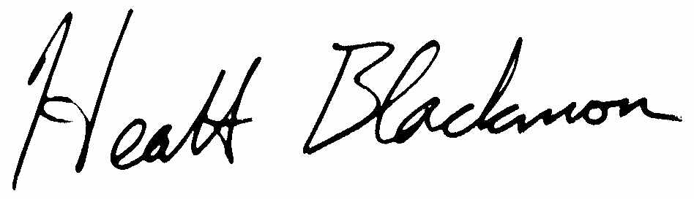
Heath Blackmon
Assistant Professor
Department of Biology
Texas A&M University
blackmon@tamu.edu

